# Count Vowel From Txt File and Git Command

1. git init

1. Git add .
2. Git commit -m “ “
3. Git push

1. Git checkout
2. Git branch
3. Git pull

1. Git rebase -I HEAD~3

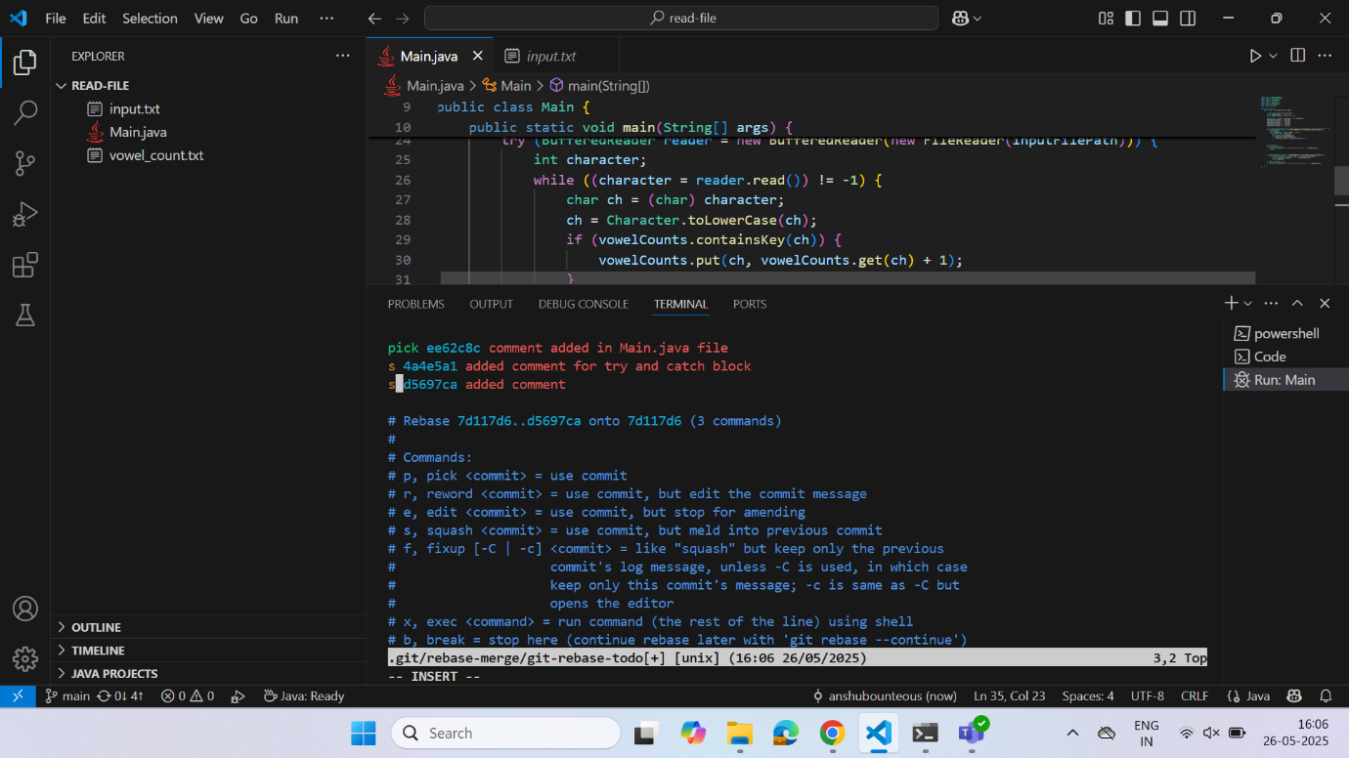

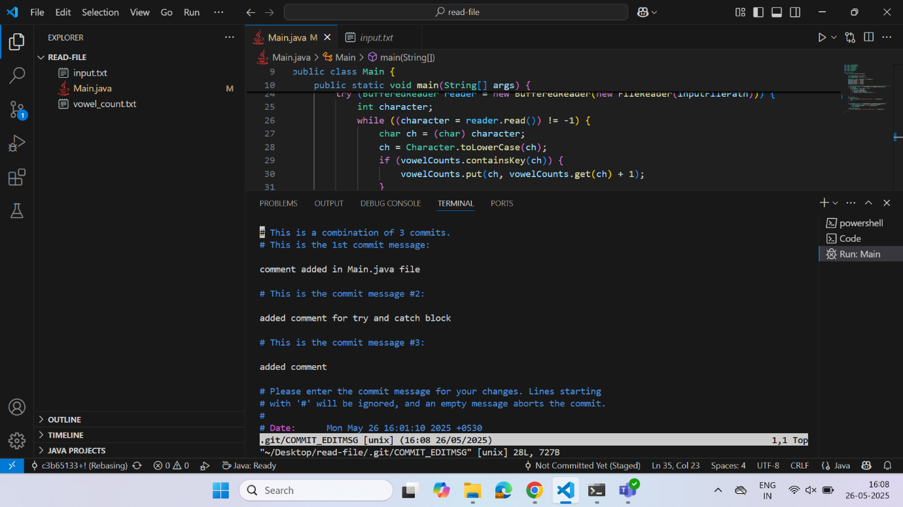

1. Git Stash

